**Basic Linux commands**

1. **To view what’s written in file.**

**Cat: -**

Cat (Concatenate) command is used in Linux. It reads data from the file and gives their content as output. It helps to create, view, concatenate files.

1. **To change access permission of files.**

Every file in Linux has following 3 permissions defined for all 3 owners.

**Read:**

This permission gives you the authority to open and read a file. Read permission gives your ability to lists its content.

**Write:**

This permission gives you the authority to modify the contents of a file. The write permission on a directory gives you the authority to add , remove and rename files in the directory.

**Execute:**

This permission gives you the authority to run the program, without this permission you can create and modify the program but will not able to execute.

We can use **“chmod”** command which stands for Change Mode. We can set permission on a file/directory for the owner, group and others

1. **To check which commands, you have run till now**

**history** command is used to view the previously executed command. This feature was not available in the Bourne shell. Bash and Korn support this feature in which every command executed is treated as the event and is associated with an event number using which they can be recalled and changed if required. These commands are saved in a history file.

1. **To remove the directory/folder.**

If the directory still contains files or subdirectories, the rmdir command does not remove the directory. To remove a directory and all its contents, including any subdirectories and files, use the rm command with the recursive option, **-r**.

1. **To create a fruits.txt file and to view its content**

Here touch command is used to create new fruits.txt file and to view the content of the file cat command is used which I have described earlier.

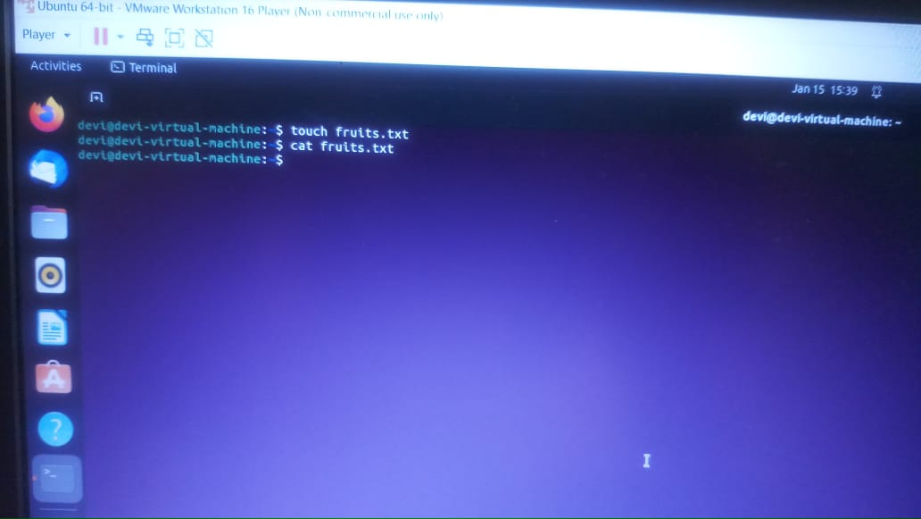

1. Adding contents in devops.txt

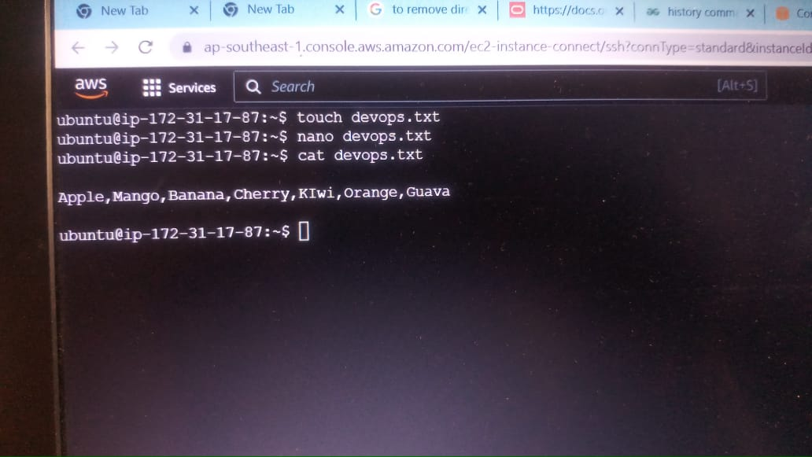

Firstly, I have used touch command to add a new file devops.txt and then I have added some contents into it by using nano command.

1. Write the command to see top three fruits from file

Here we can use head command to see top three fruits from fruits.txt file

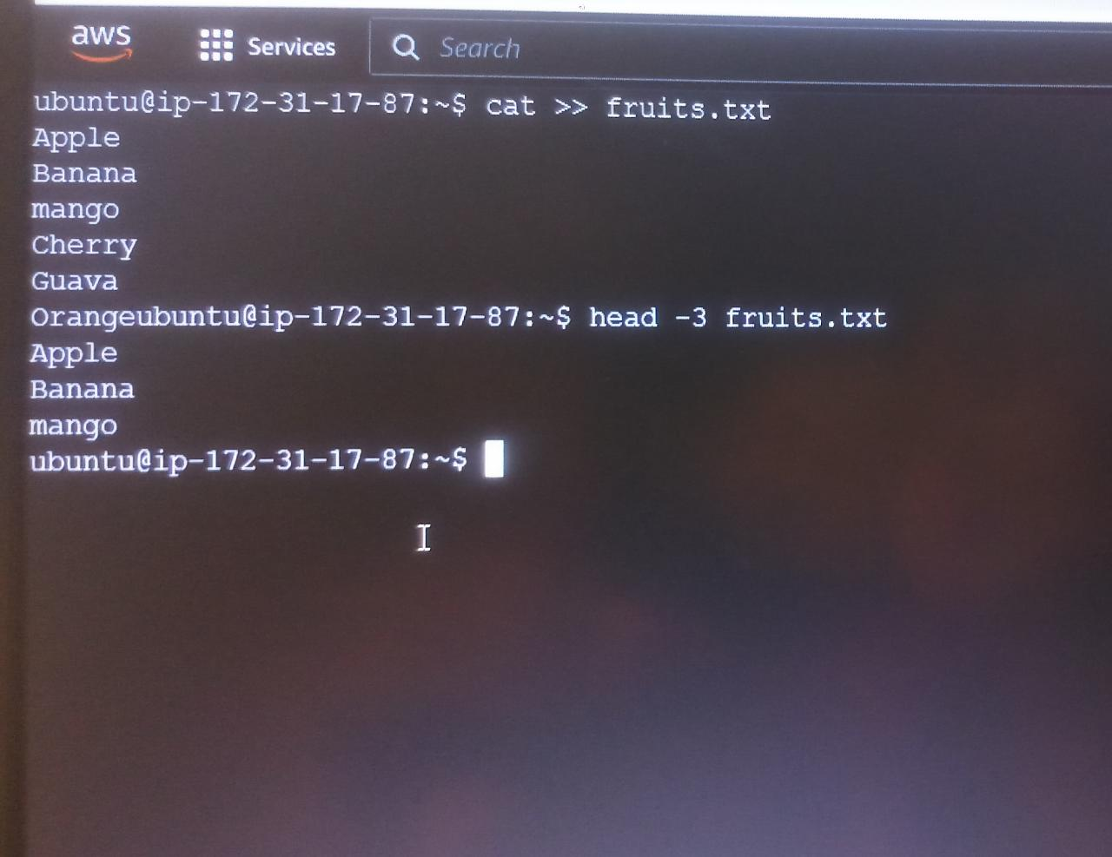

1. Write the command to see bottom three fruits from file

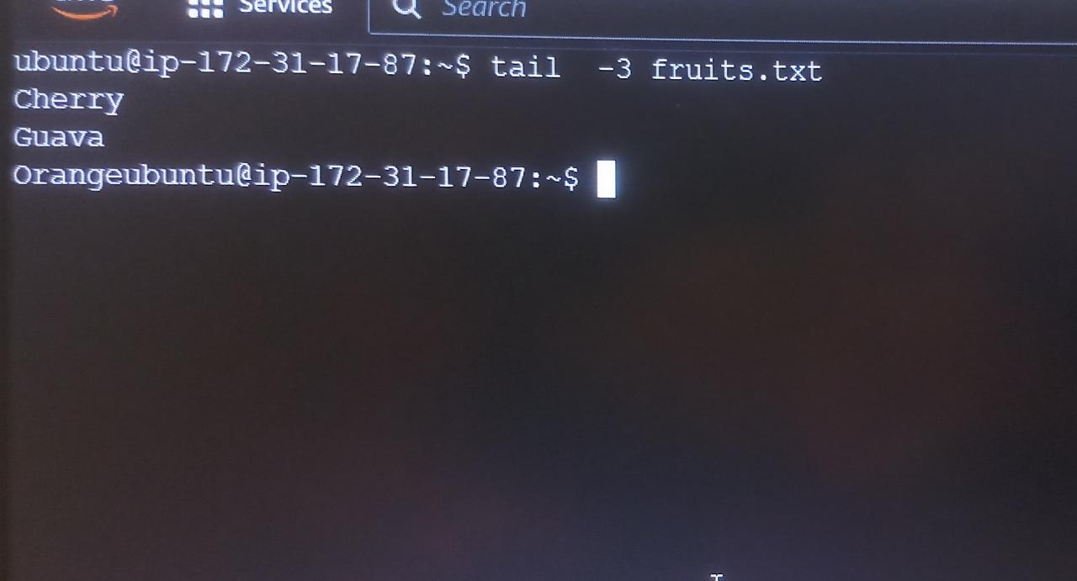

By using tail command you can see the bottom lines.

1. To create another file Color.txt and to view its content

By using touch command, we can create Color.txt file and using Cat >> Color.txt we can add contents into file.

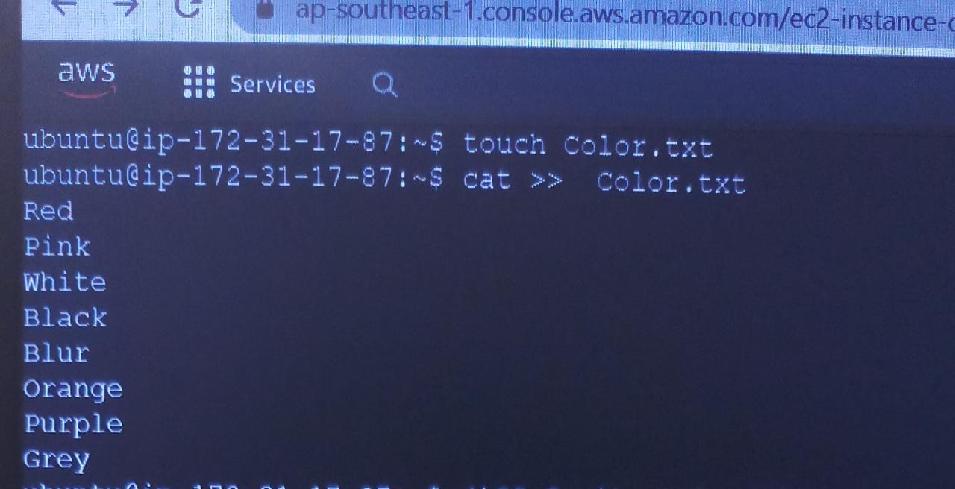

1. **Add contents into Color.txt file**

In the above picture contents are added by using cat command

1. **To find the difference between fruits.txt and Color.txt file**

diff stands for **difference**. This command is used to display the differences in the files by comparing the files line by line.

